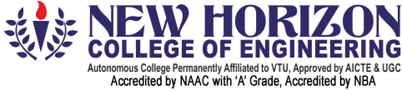

Department of Artificial Intelligence & Machine Learning
Academic Year 2025-26 (EVEN)
Report
for
Environmental Studies (22ESK57)
On
“Waste Management – Plastic Waste in a Town A town faces overflowing landfills due to high plastic use. Students explore segregation challenges, recycling, and zero-waste strategies like composting and cloth bags.”
By
Name USN
Shreyash B Kone 1NH24AI412

Under the Guidance of
Dr. Sonia Maria D’Souza
Sr. Asst. Professor,
Dept. of Artificial Intelligence & Machine Learning,
New Horizon College of Engineering,
Bangalore-560103

Department of Artificial Intelligence & Machine Learning
CERTIFICATE

Certified that the Mini Project- I with the subject code 22AIM48 work entitled “Gesture Talk AI -Real-Time Sign Language Detection to Text and Voice” carried out by Mr. Prajwal H N - USN 1NH24AI407, Mr. Omkar Maruti Naik – USN 1NH24AI405, Mr. Santhosha – USN 1NH24AI409. It is certified that all corrections/suggestions indicated for Internal Assessment have been incorporated in the report. The project report has been approved as it satisfies the academic requirements in respect of Mini Project work.

Ms. K S Shashikala Dr. N.V. Uma Reddy
Internal Guide Professor & Head of Department

External Examiner Signature with Date:

1.
2.

